s

|  |  |  |
| --- | --- | --- |
| **SR. NO.** | **CONTENT** | **PAGE** |
| 1 | Brief Description | 3 |
| 2 | Navigation Bar Section | 4 |
| 3 | Colour Section | 10 |
| 4 | Typography Section | 11 |
| 5 | Wireframe Section | 12 |
| 6 | Branding Section | 18 |

**BRIEF DESCRIPTION OF WEB SITE**

This is a web site created using HTML5, CSS3 and JS, it demonstrate simple designing ability achieve by knowledge of HTML and CSS, this is the responsive site created to demonstrate what type of work I am able to do in area of web development.

In this site there are few section which I use to display my past work on website and there are total 6 pages included in Navigation Bar which will be describe in further parts of this documentation I tried to apply various JS and Extended function of CSS3 to demonstrate responsive site functionality I took an idea and adopt some technique from *“Responsee”* which is framework for HTML-CSS just like *“Foundation”*. In navigation bar I included social media links so user can connect to my social media pages at any time.

Different Pages of site illustrate Different area of functionalities, HOME page give functionality of slider, ABOUT ME page demonstrate text document and picture area on page, PROJECT and SERVICES pages gives idea about creating picture gallery, LOCATION page demonstrate use of maps on HTML page, CONTACT page give ability to demonstrate active functional contact form which sends email on submitting the data.

**NAVIGATION BAR SECTION**

* Navigation bar set at top section of page which looks like image below.
* Quick links to get connected with developer social media Pages.

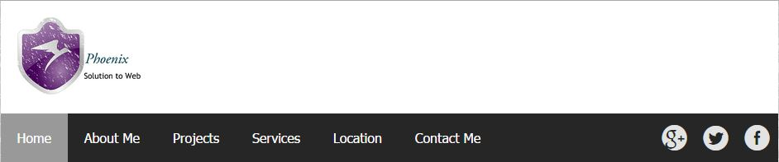

* Clicking on “HOME” page of web site which looks like image below. Which contain the slider basically demonstrating my past work samples. And overview of entire site on one page.

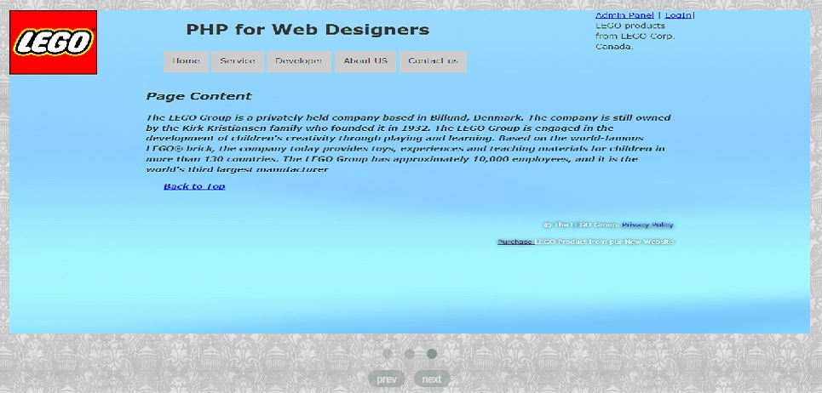

* The second page is about me.

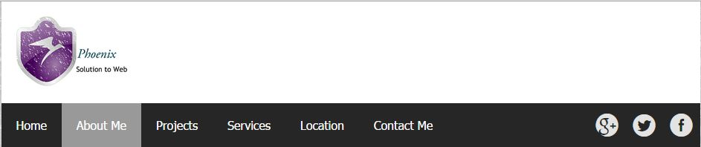

* Which redirect to the page on which there is some description about myself.

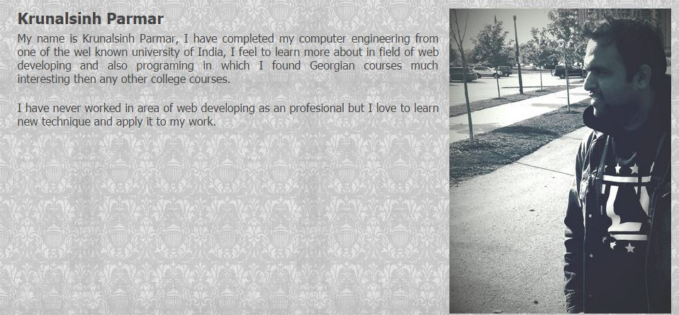

* Third page displays a detail of my projects.

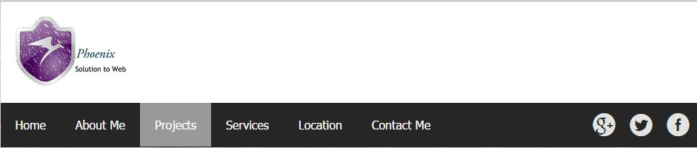

* Which redirect to the page containing the project works with images and description of project and that looks like below image.

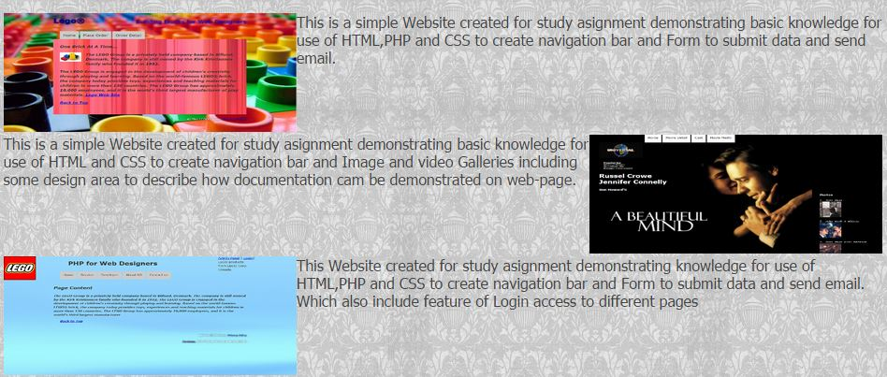

* Fourth page is about services which are provided by company.

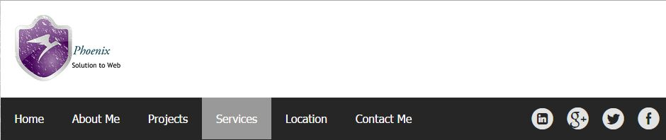

* On clicking this page will redirect to the page where image and description will describe which services provided by our company. It looks like the image below.



* Page 5 is about location which redirect to page where Google map is plotted to display my address.

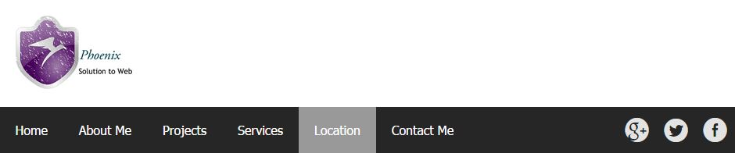

* That looks like image below.

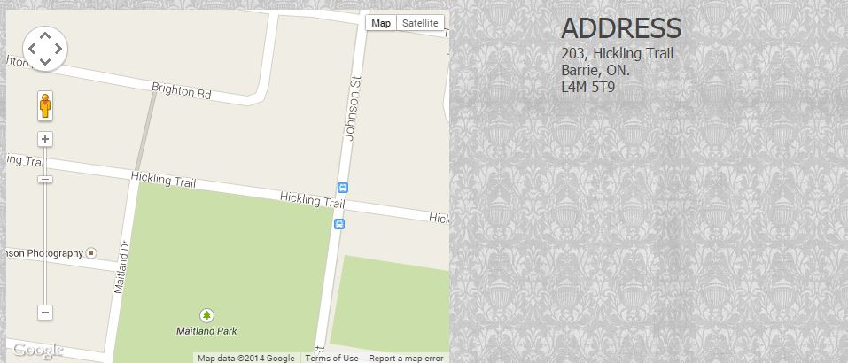

* Last page is about contact form which allow guest user to fill form like name, email, Telephone, Website and massage.

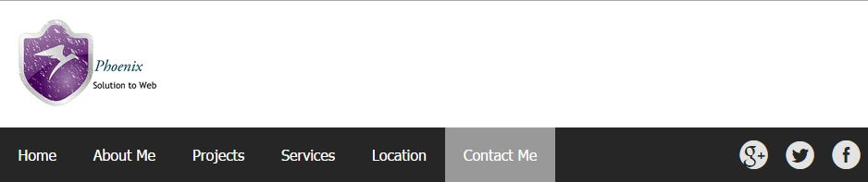

* That information will directly forward to my email address.

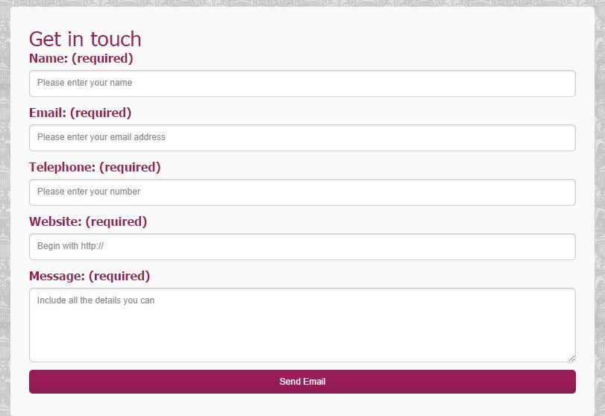

**COLOURS SECTION**

|  |  |
| --- | --- |
| **COLOR CODE AND SWATCHES** | **USE OF COLOR** |
| C:\Users\Jay Mata Di\Desktop\ASSIGNMENT1_DOC_SUP_IMG\c1.JPG | Background of navigation bar |
| C:\Users\Jay Mata Di\Desktop\ASSIGNMENT1_DOC_SUP_IMG\c2.JPG | Active page on navigation bar |
| C:\Users\Jay Mata Di\Desktop\ASSIGNMENT1_DOC_SUP_IMG\c4.JPG | Footer background |
| C:\Users\Jay Mata Di\Desktop\ASSIGNMENT1_DOC_SUP_IMG\c4.JPG | Navigation Links |
| C:\Users\Jay Mata Di\Desktop\ASSIGNMENT1_DOC_SUP_IMG\c2.JPG | Navigation Links Hover |
| C:\Users\Jay Mata Di\Desktop\ASSIGNMENT1_DOC_SUP_IMG\c7.JPG | Border colour |
| C:\Users\Jay Mata Di\Desktop\ASSIGNMENT1_DOC_SUP_IMG\c8.JPG | Navigation Visited links |
| C:\Users\Jay Mata Di\Desktop\ASSIGNMENT1_DOC_SUP_IMG\c9.JPG | Form Background |

**TYPOGRAPHY SECTION** 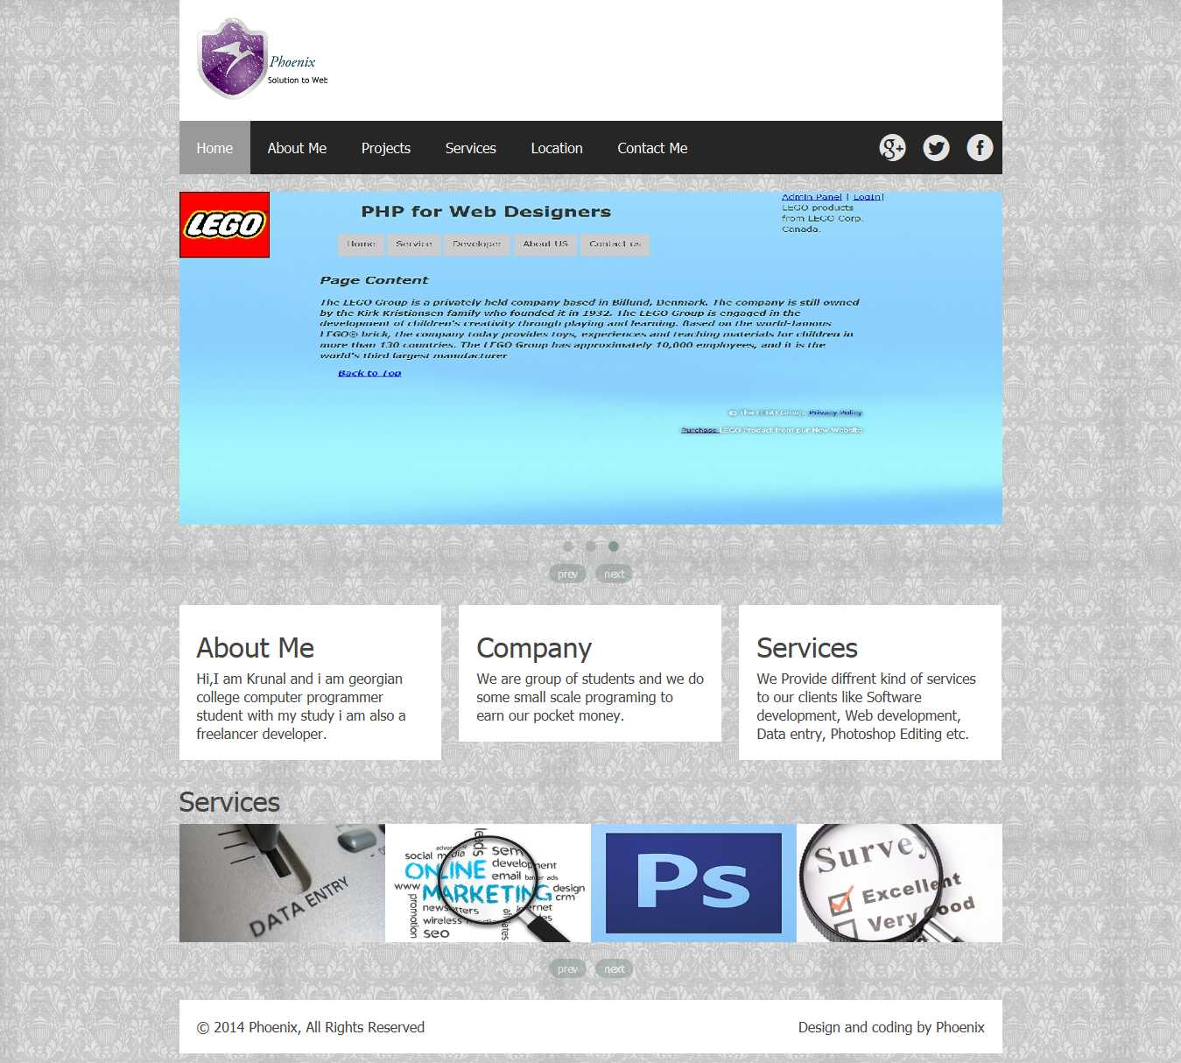

Font Type: - Tahoma

Colour: - # 444

**WIREFRAMES SECTION**

HOME PAGE

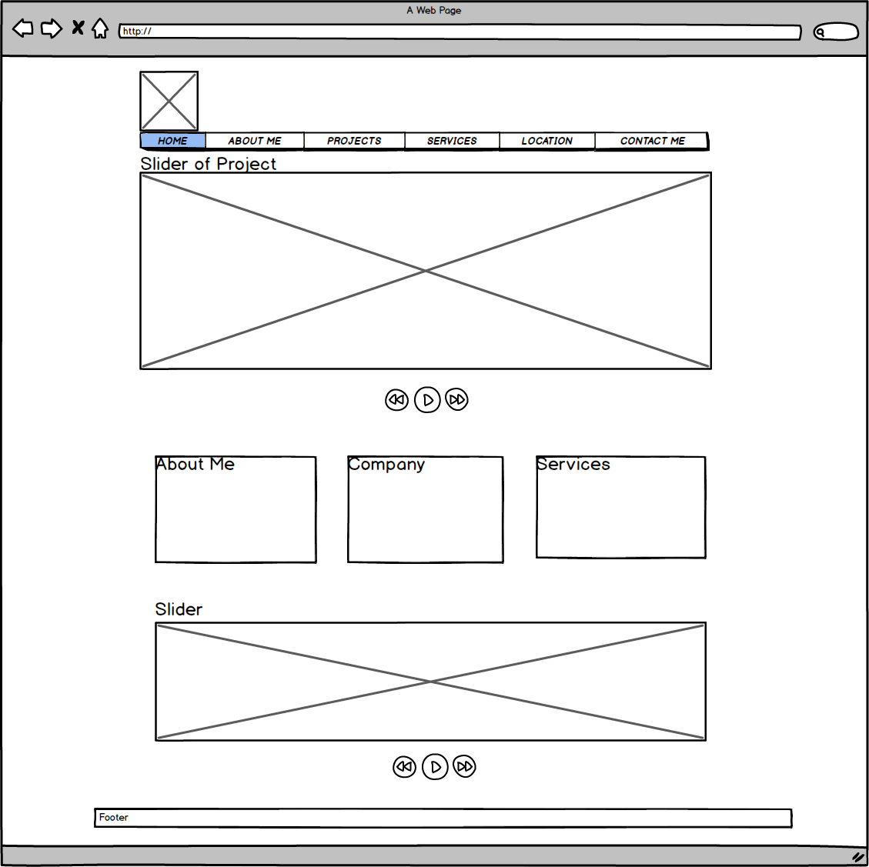

ABOUT ME

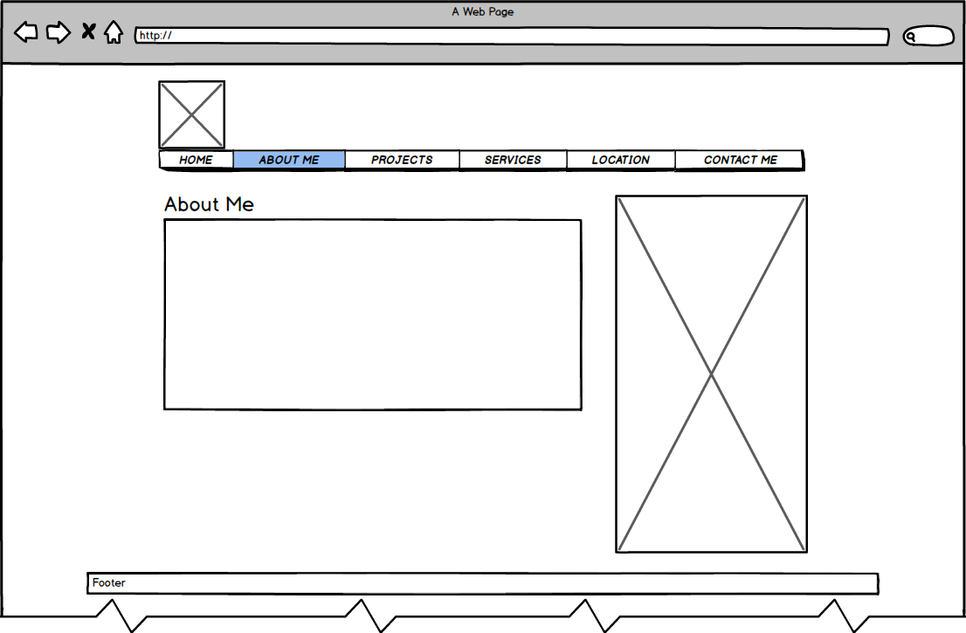

Projects

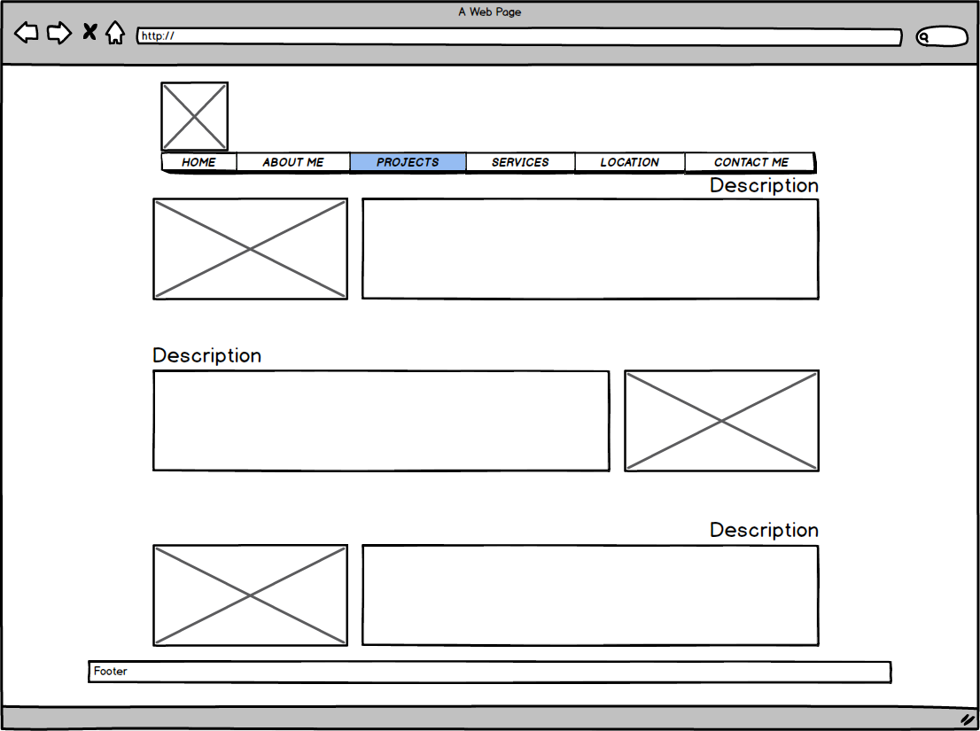

Services

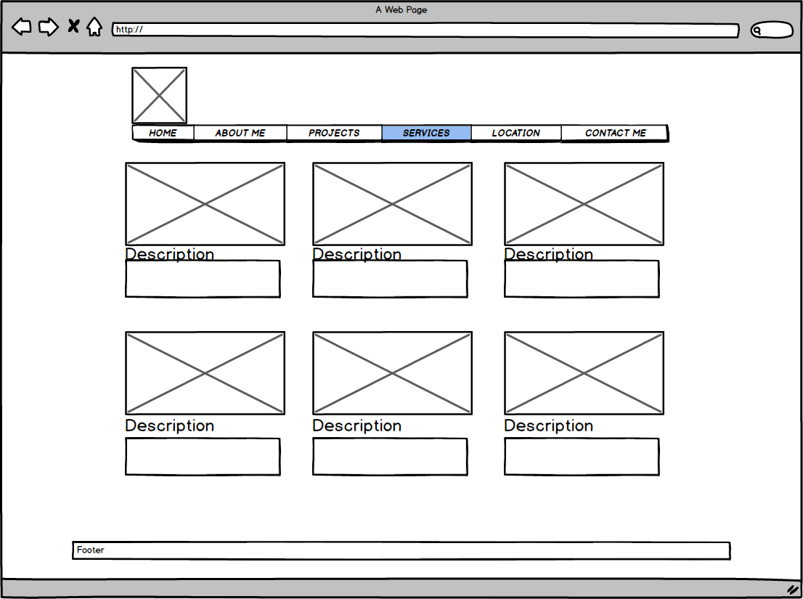

Location

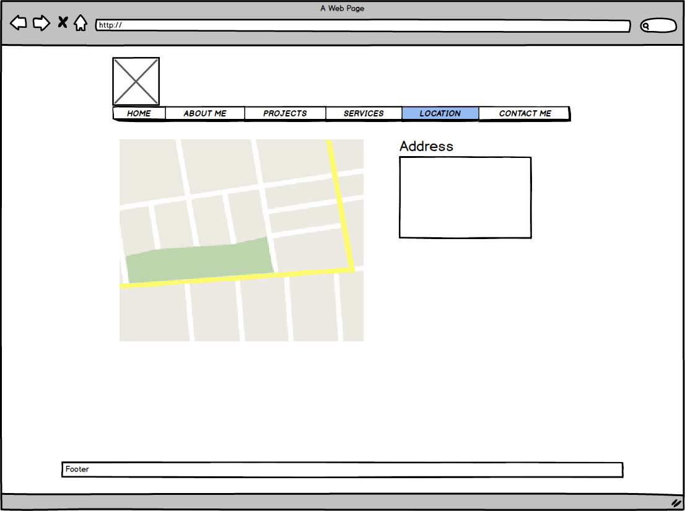

Contact Me

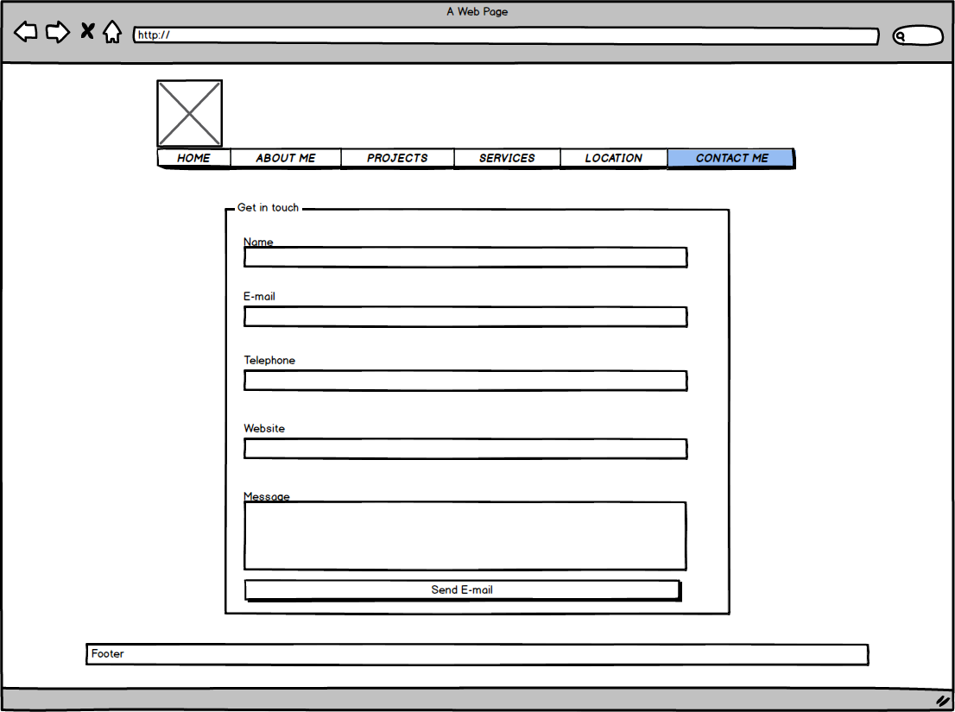

**BRANDING SECTION**

**Navigation bar Template:-**

****

**Home Page Slider:-**

****

**About Me page Template:**

****

**Project Page:-**

* Description of project with image (screenshots).

****

**Contact me page:-**

* Contact form with information input items, to allow guest enter Name, Telephone, Message and Email, Website. ****